MILESTONE 2 REPORT
Scheduling and Design
Student Mentoring and Career Support Platform
Team 032 – Himalayan Coders | IIT Madras
Prepared by: Ankur Maurya, Adnan Mustafa, Himanshu Rathor, Hemendra Kumar Sharma, Bojannagari Pavan Kumar Reddy
Draft for team review. Dates, meeting times, owners and sample data must be confirmed.

1. Design of Components
Component | Responsibilities | Notes
Student UI | Dashboard, goals/profile, request status, assigned connection, feedback | No public mentor directory
Mentor UI | Edit own professional profile and availability | Mentor edits own profile
Coordinator/Admin UI | Review needs, manage mentor records, assign matches, monitor delays | Role restricted
API/workflow | Authentication, authorization, validation, status transitions, audit | Proposed only
Data layer | Students, mentors, requests, availability, sessions and feedback | Relational DB proposed
Flow: browser UI → authenticated API → validation/workflow → relational database. Enforce authorization server-side.

2. Class Diagram
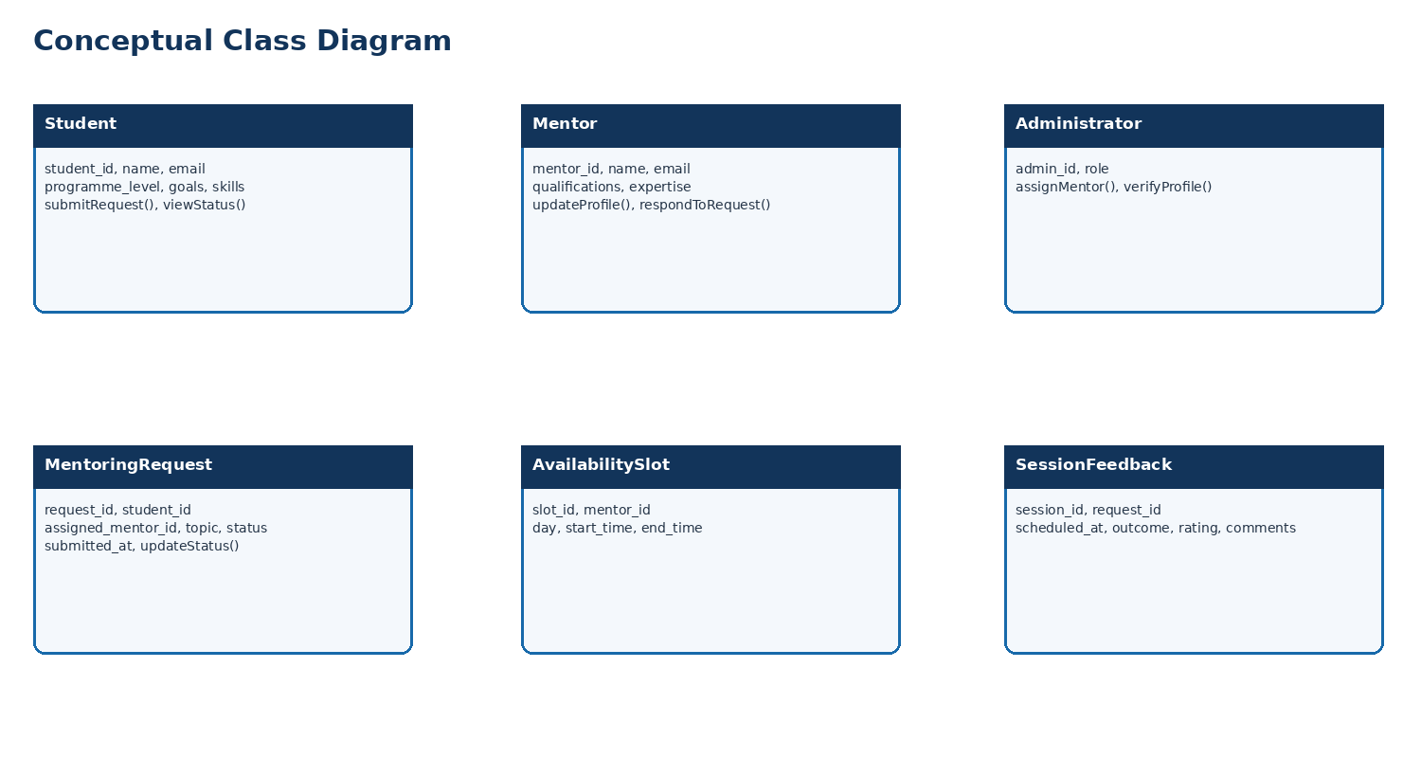

3. Database Design
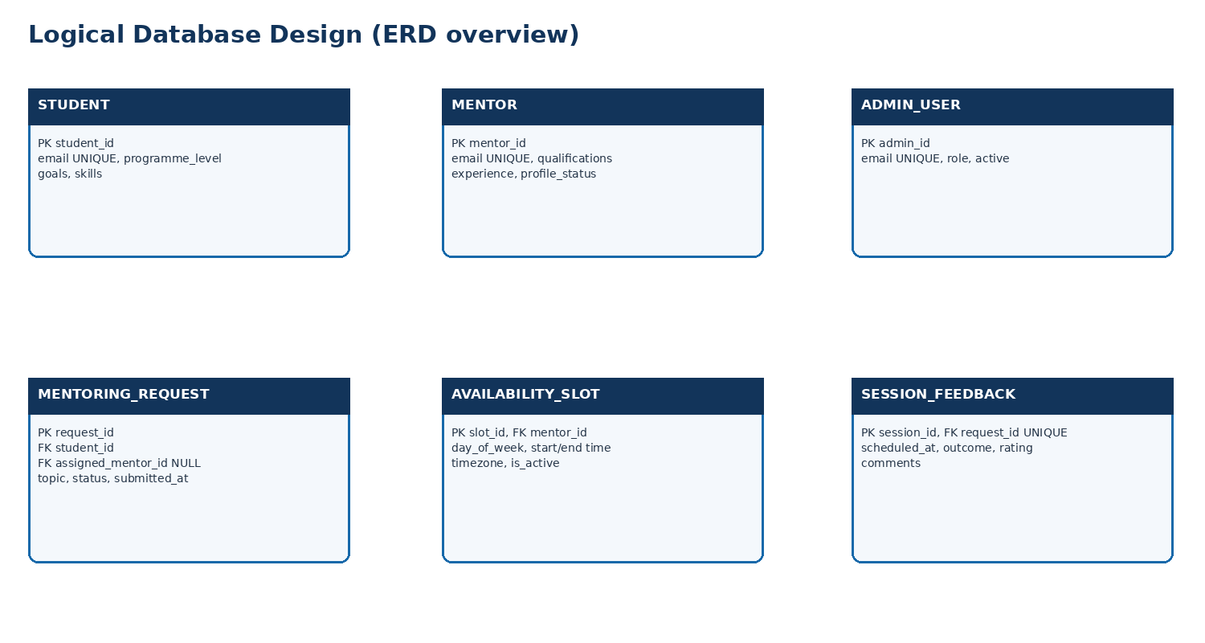
Table | Key fields | Purpose
STUDENT | PK student_id; email UNIQUE; goals; skills | Student needs
MENTOR | PK mentor_id; email UNIQUE; qualifications; experience | Mentor profile
ADMIN_USER | PK admin_id; email UNIQUE; role | Admin access
MENTORING_REQUEST | PK request_id; FK student_id; FK mentor_id NULL; status | Workflow
AVAILABILITY_SLOT | PK slot_id; FK mentor_id; time window | Availability
SESSION_FEEDBACK | PK session_id; FK request_id UNIQUE; rating/comments | Session feedback

4. Sprint Schedule
Sprint | Dates | Scope | Exit criteria
Sprint 0 | 2–6 Nov | Scope, roles, diagrams, issues | Baseline reviewed
Sprint 1 | 9–20 Nov | Student UI, requests, mentor profile | Pages reviewed
Sprint 2 | 23 Nov–4 Dec | Coordinator UI, data/API, validation | Design reviewed
Hardening | 7–11 Dec | Testing, report, screenshots, README | Package reviewed
Tentative schedule for 2 November–11 December 2026. PM and Scrum Master must discuss it with the whole team before finalizing.

5. Scrum Meetings and Minutes
Meeting | Cadence | Proposed time | Output
Planning | First day of sprint | Mon 7:30–8:15 PM | Goal/stories/owners
Async stand-up | Weekdays | By 10 PM | Progress/blockers
Review | Last Friday | 7:30–8 PM | Demo/feedback
Retro | After review | 8–8:30 PM | Improvement actions
Refinement | Wednesday | 7:30–8 PM | Clarify backlog
Minutes template: Date; attendees; facilitator; sprint goal; decisions; progress; blockers/risks; actions with owners and due dates; next meeting. Record actual minutes after meetings.

6. Gantt Chart
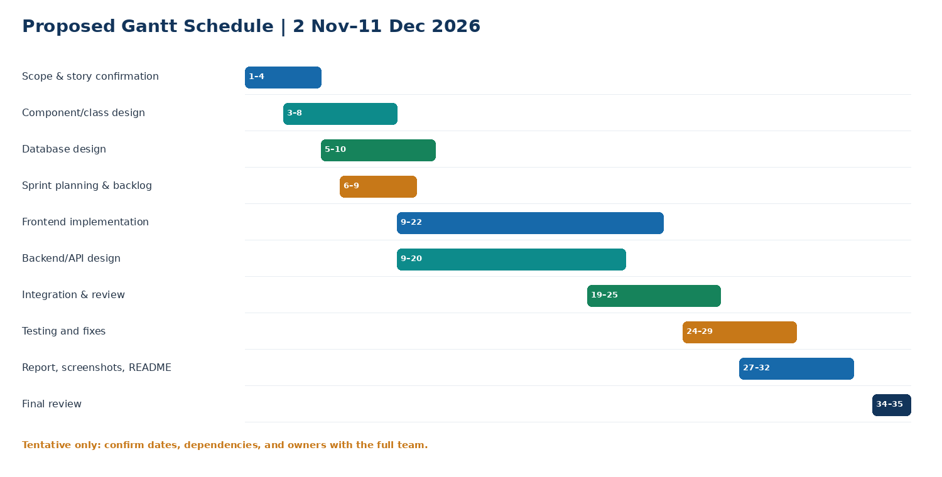

7. Kanban Board
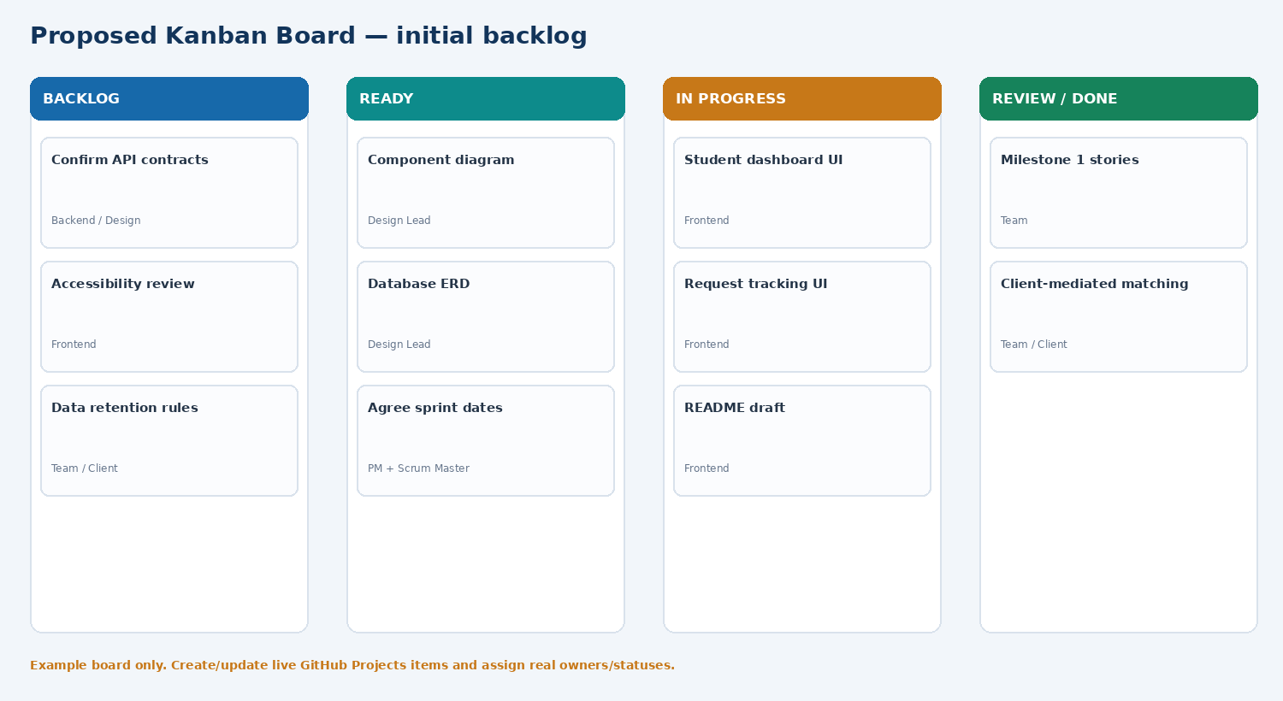

8. Frontend Screenshots
Static UI mockups only. Replace with real browser screenshots after implementation.

Student dashboard
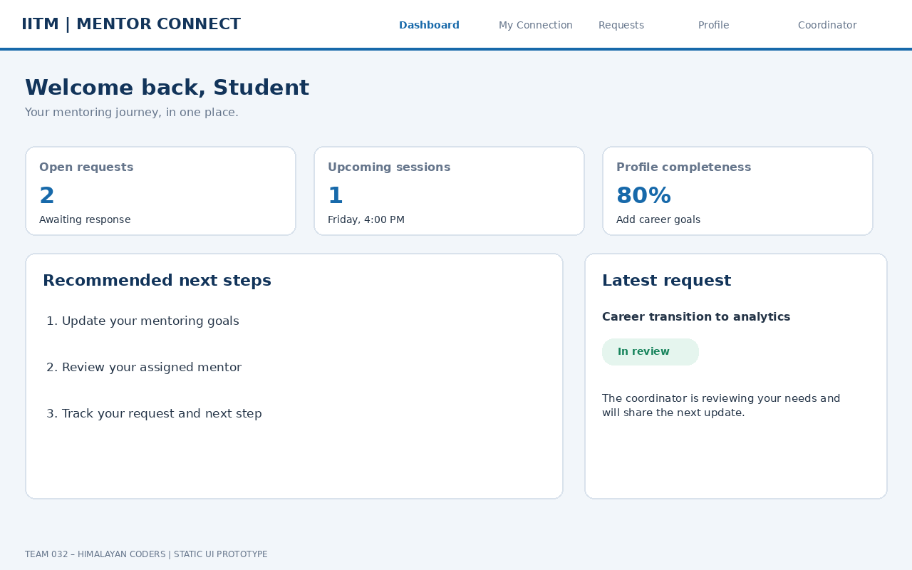

Assigned mentor
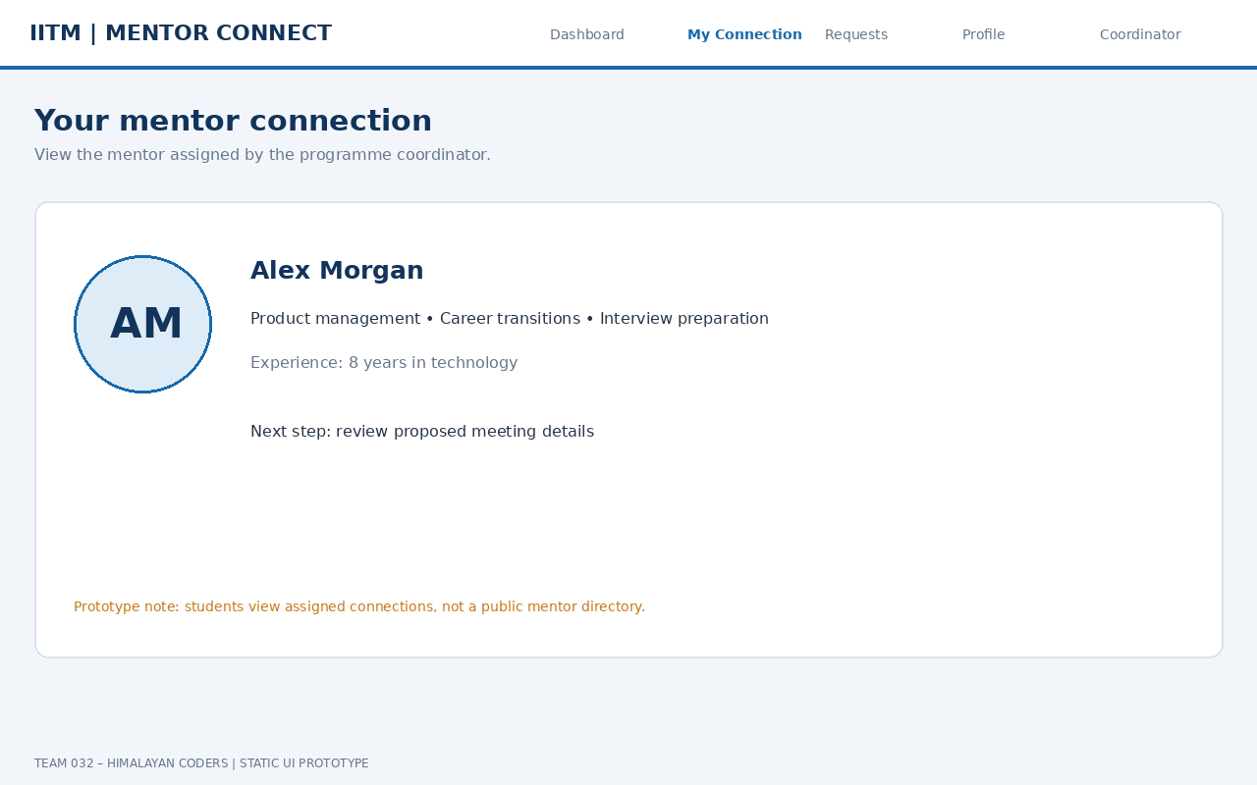

Request tracking
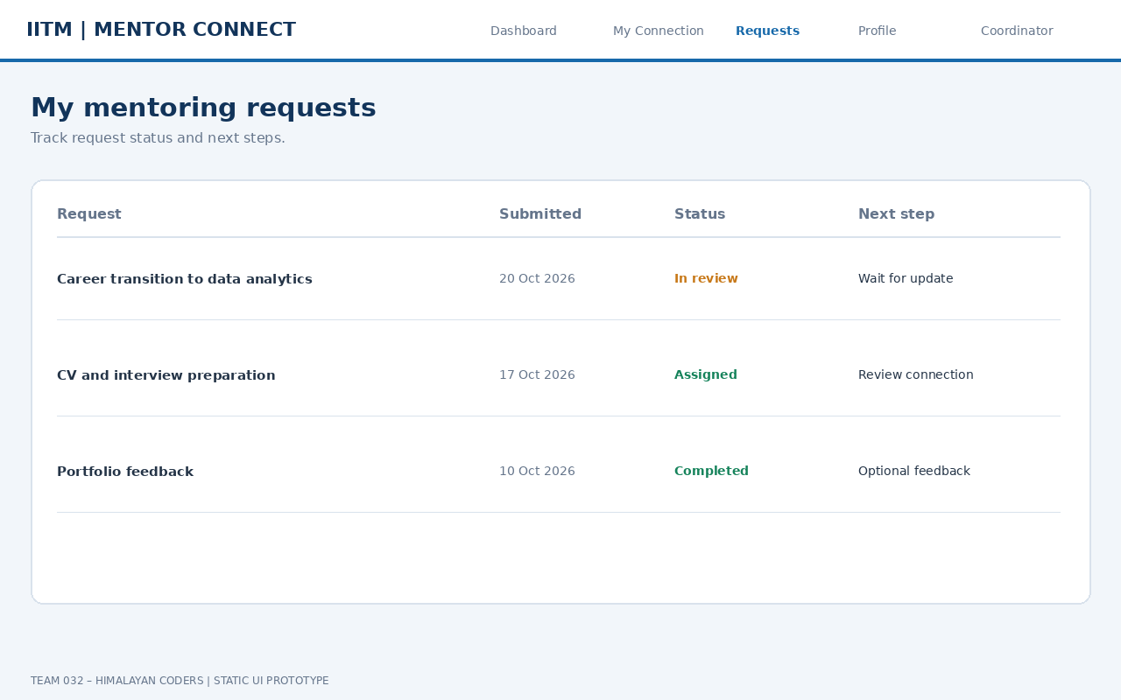

Mentor profile editor
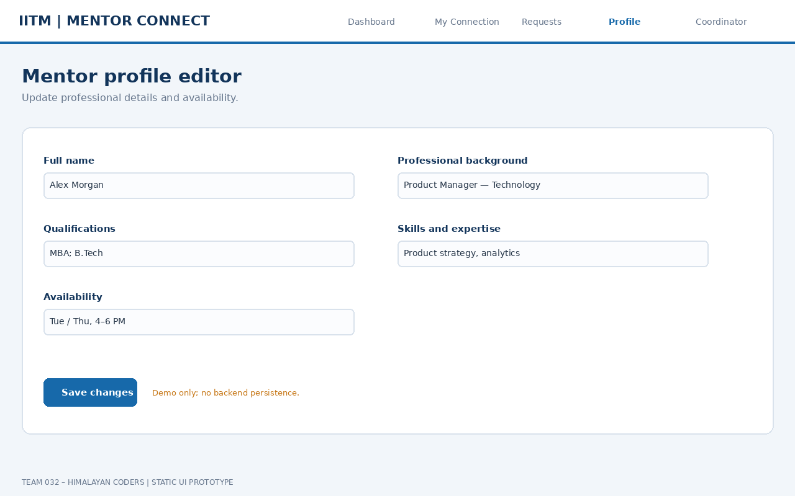

Coordinator dashboard
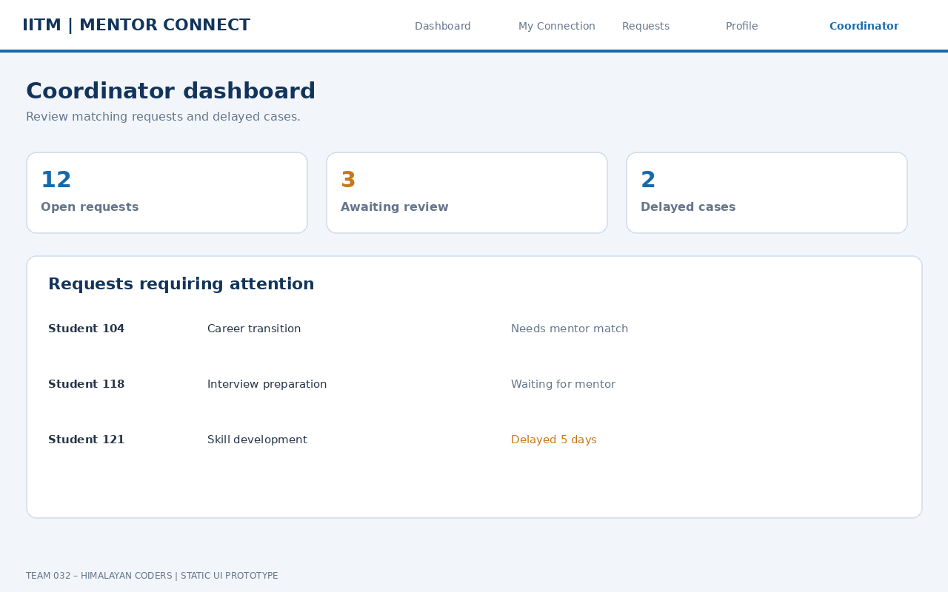

9. Frontend Code and README
Unzip frontend ZIP, open frontend/index.html in a modern browser. No install required. Prototype uses sample data and has no backend, database, authentication or persistence.

10. Risks and Open Questions
- Confirm profile-edit permissions and roles.
- Confirm request status transitions and rematch process.
- Confirm scheduling workflow and notifications.
- Define privacy, retention and audit requirements.
- Confirm technical stack and authentication.
- Confirm team capacity, dates and code reviewer.

11. Submission Checklist
☐ Component design
☐ Class diagram
☐ Database design
☐ Sprint schedule
☐ Actual Scrum minutes
☐ Gantt screenshot
☐ Live Kanban screenshot
☐ Real frontend screenshots
☐ Frontend ZIP and README
☐ Code reviewer assigned
☐ Team schedule approval
☐ TA/client feedback

